6. Write a C program to find Fibonacci series using Recursion

**Aim:** To write a C program to generate the Fibonacci series up to a given number of terms using recursion.

**Algorithm**

1. Start the program.
2. Define a recursive function fibonacci(n):
   * If n == 0, return 0.
   * If n == 1, return 1.
   * Otherwise, return fibonacci(n-1) + fibonacci(n-2).
3. In the main function:
   * Read the number of terms n from the user.
   * Use a loop from 0 to n-1 and call fibonacci(i) to display each term.
4. Print the Fibonacci series.
5. Stop the program.

**Program**

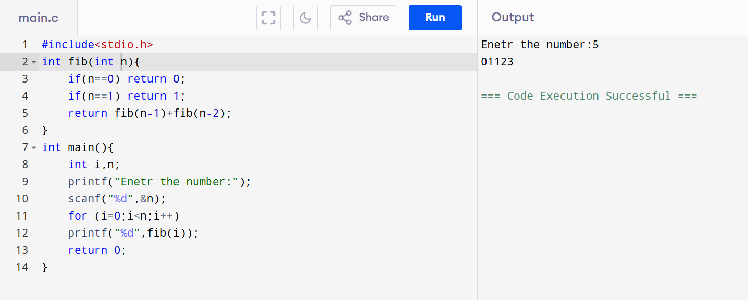

**Result:** Thus, the C program to generate the Fibonacci series using recursion was successfully executed.